ITA0305- Mobile Computing
LAB EXPERIMENT
Name: G.Ganesh
Reg NO:192373008

11. Design a wireframe for a mobile application that incorporates security measures
using Figma
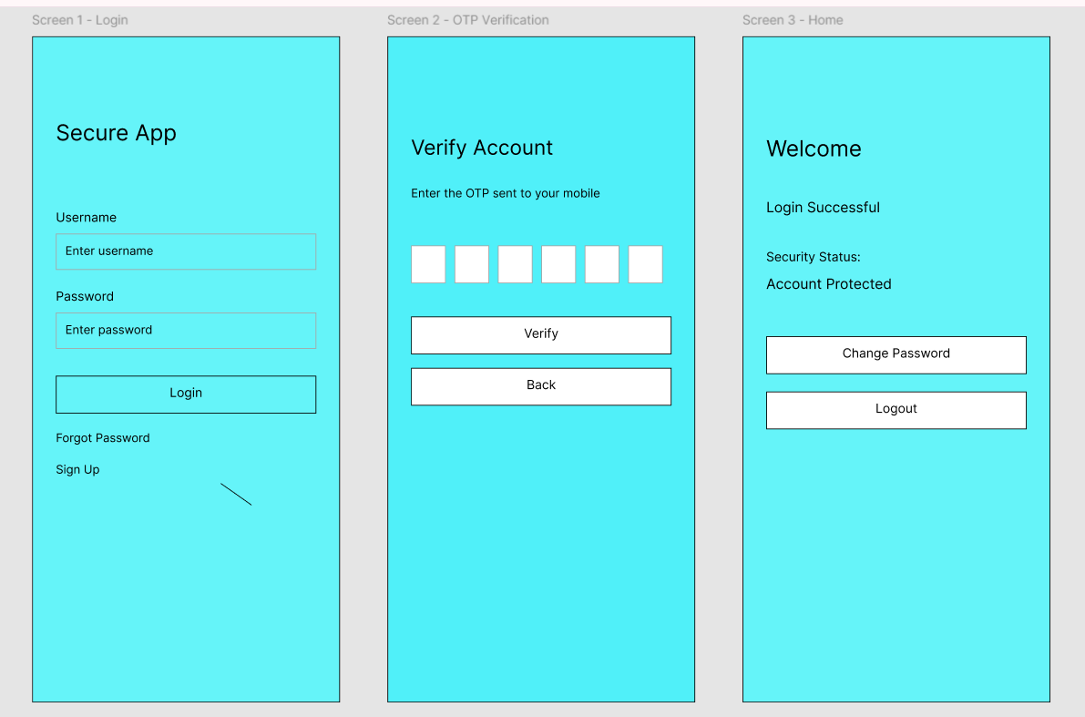

https://www.figma.com/design/rNopfhGaziANtNyuNp1D5S/program11?node-id=0-1&p=f&t=oGtrzsldNM3oi1Th-0

